# Plan De Pruebas

## Clientes

### Crear Cliente

**CURL:**

curl --location 'http://localhost:8084/api/clientes' \

--header 'Content-Type: application/json' \

--**data** '{

    "customerId": "CUST0002",

    "name": "Marianela Montalvo",

    "gender": "Femenino",

    "age": 20,

    "identification": "1234567802",

    "address": "Amazonas y NNUU",

    "phone": "097548965",

    "password": "5678",

    "state": true

}'

**RESPONSE:**

{

    "customerId": "CUST0002",

    "name": "Marianela Montalvo",

    "gender": "Femenino",

    "age": 20,

    "identification": "1234567802",

    "address": "Amazonas y NNUU",

    "phone": "097548965",

    "password": "5678",

    "state": **true**

}

**POSTMAN:**

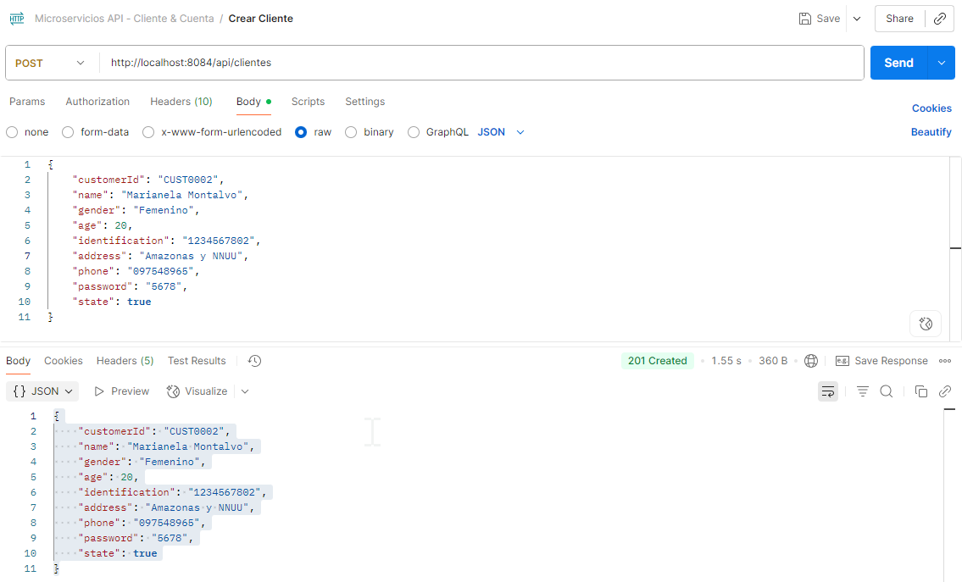

### Actualizar Cliente

**CURL:**

curl --location --request PUT 'http://localhost:8084/api/clientes/CUST0002' \

--header 'Content-Type: application/json' \

--**data** '{

    "address": "Pillaro San Miguelito",

    "phone": "0980298828",

    "state": true

}'

**RESPONSE:**

{

    "customerId": "CUST0002",

    "name": "Marianela Montalvo",

    "gender": "Femenino",

    "age": 20,

    "identification": "1234567802",

    "address": "Pillaro San Miguelito",

    "phone": "0980298828",

    "password": "5678",

    "state": **true**

}

**POSTMAN:**

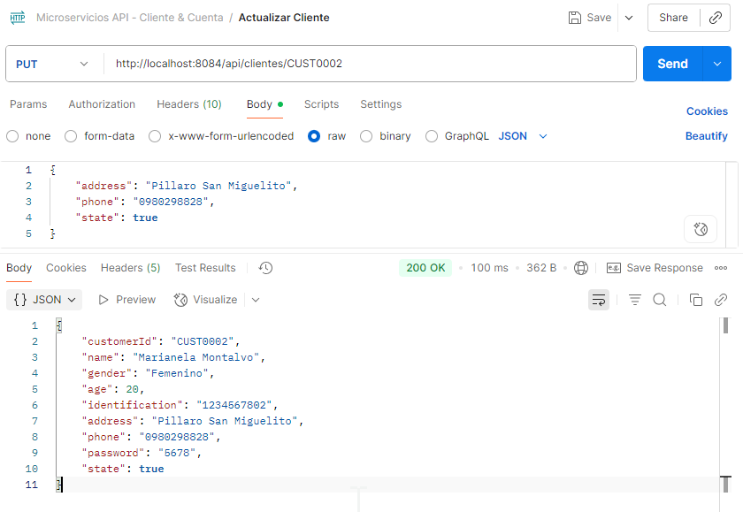

### Consultar Cliente por ClienteId

**CURL:**

curl --location 'http://localhost:8084/api/clientes/CUST0001' \

--header 'Content-Type: application/json' \

--data ''

**RESPONSE:**

{

    "customerId": "CUST0001",

    "name": "Jose Lema",

    "gender": "Masculino",

    "age": 30,

    "identification": "1234567801",

    "address": "Pillaro San Miguelito",

    "phone": "0980298828",

    "password": "1234",

    "state": **true**

}

**POSTMAN:**

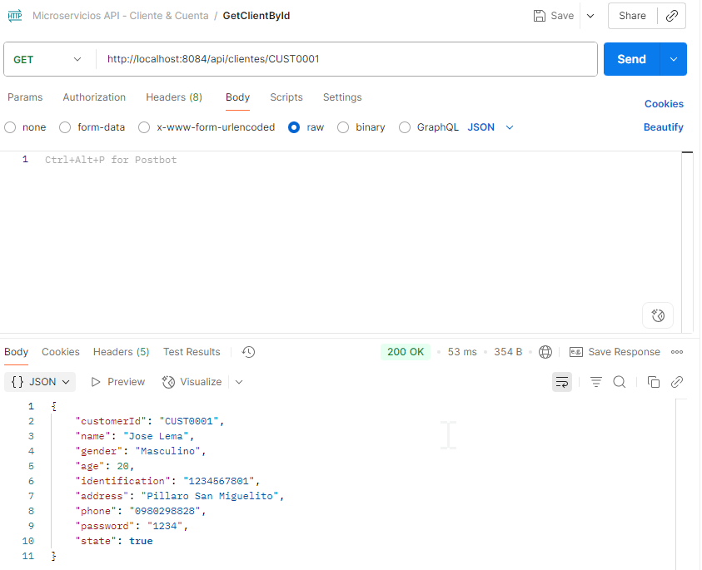

### Eliminar Cliente

**CURL:**

curl --location --request DELETE 'http://localhost:8080/api/clientes/CUST0001' \

--header 'Content-Type: application/json'

**POSTMAN:**

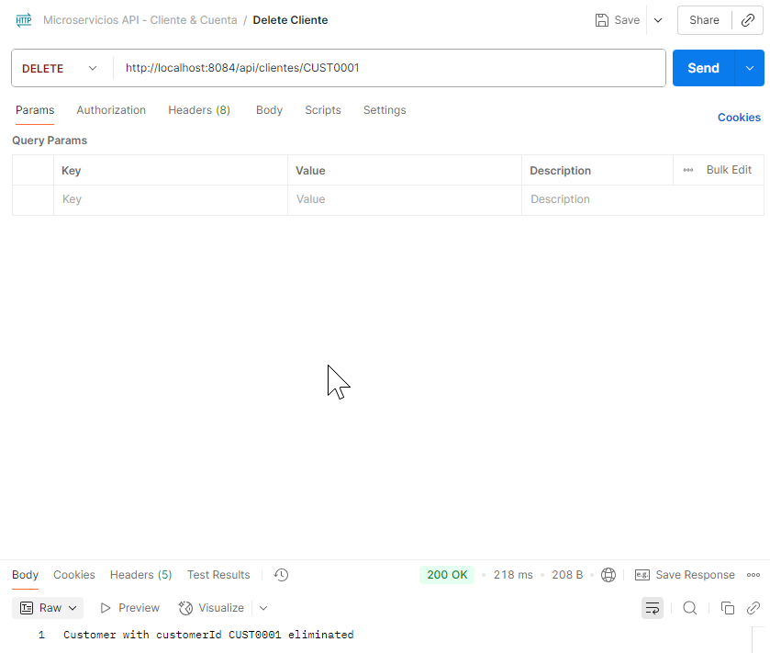

## Cuentas

### Crear Cuenta

**CURL:**

curl --location 'http://localhost:8085/api/cuentas' \

--header 'Content-Type: application/json' \

--**data** '{

    "accountNumber": "225487",

    "accountType": "Corriente",

    "initialBalance": 100,

    "state": true,

    "customerId": "CUST0002"

}'

**RESPONSE:**

{

    "id": 2,

    "accountNumber": "225487",

    "accountType": "Corriente",

    "initialBalance": 100,

    "state": **true**,

    "customerId": "CUST0002",

    "availableBalance": 100

}

**POSTMAN:**

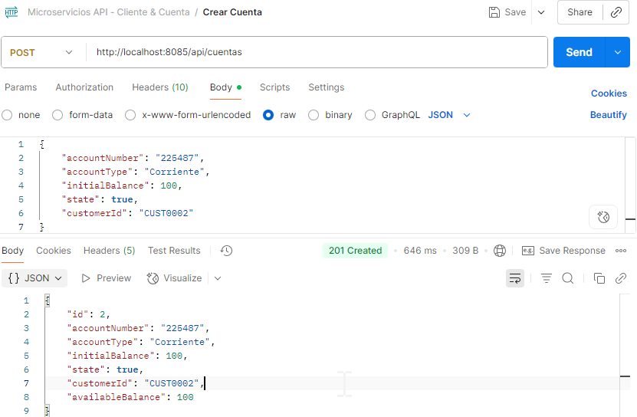

### Actualizar Cuenta

**CURL:**

curl --location --request PUT 'http://localhost:8085/api/cuentas/225487' \

--header 'Content-Type: application/json' \

--**data** '{

    "state": false

}'

**RESPONSE:**

{

    "id": 2,

    "accountNumber": "225487",

    "accountType": "Corriente",

    "initialBalance": 100.00,

    "state": **false**,

    "customerId": "CUST0002",

    "availableBalance": 100.00

}

**POSTMAN:**

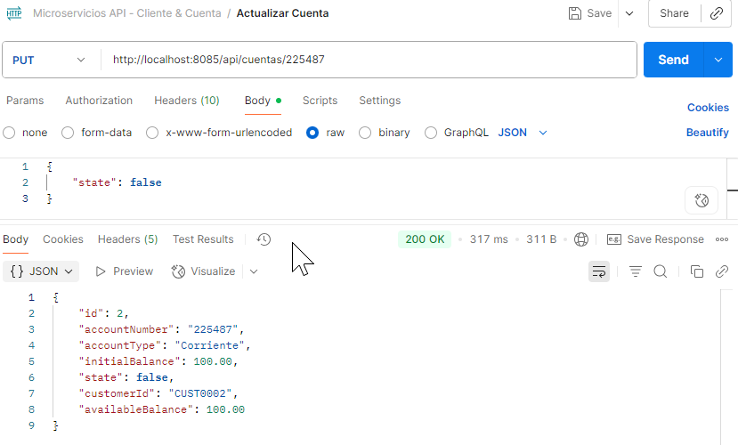

### Consultar por Número de cuenta

**CURL:**

curl --location 'http://localhost:8085/api/cuentas/225487' \

--header 'Content-Type: application/json' \

--**data** ''

**RESPONSE:**

{

    "id": 2,

    "accountNumber": "225487",

    "accountType": "Corriente",

    "initialBalance": 100.00,

    "state": **false**,

    "customerId": "CUST0002",

    "availableBalance": 100.00

}

**POSTMAN:**

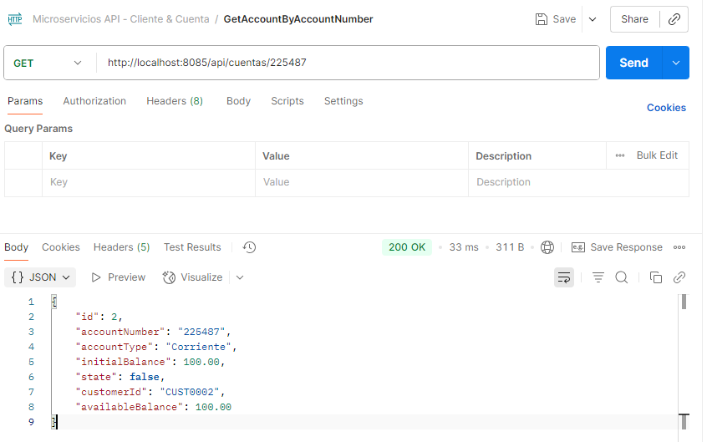

### Eliminar Cuenta

**CURL:**

curl --location --request DELETE 'http://localhost:8085/api/cuentas/478758' \

--header 'Content-Type: application/json'

**POSTMAN:**

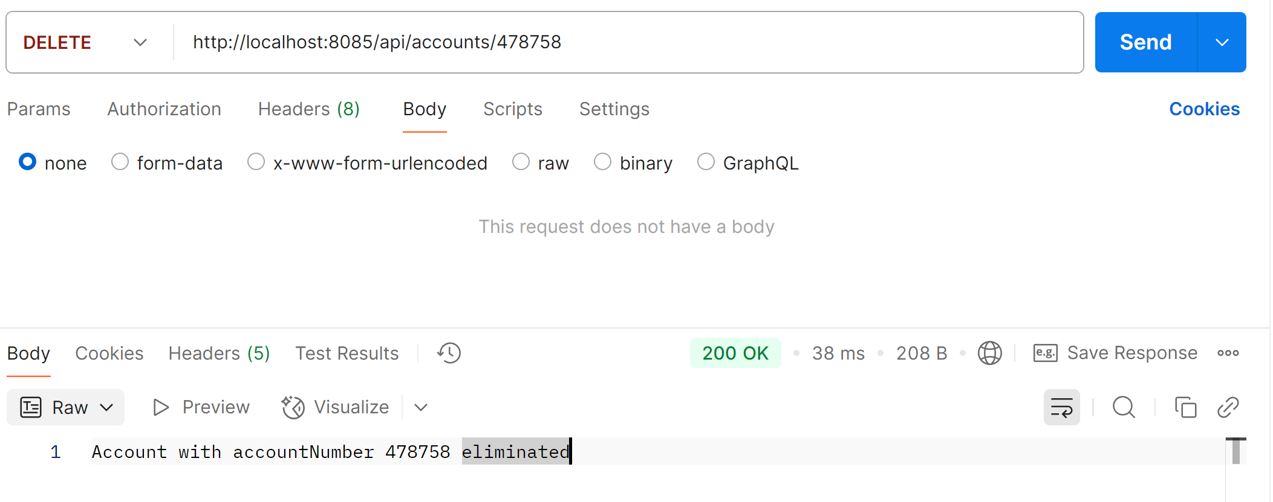

## Movimientos

### Crear movimiento

**CURL:**

curl --location 'http://localhost:8085/api/movimientos' \

--header 'Content-Type: application/json' \

--**data** '{

    "accountNumber": "225487",

    "movementType": "DEPOSITO",

    "amount": 600

}'

**RESPONSE:**

{

    "id": 2,

    "date": "2025-08-31T20:36:16.257149417",

    "movementType": "DEPOSITO",

    "amount": 600,

    "balance": 700.00,

    "accountNumber": "225487"

}

**POSTMAN:**

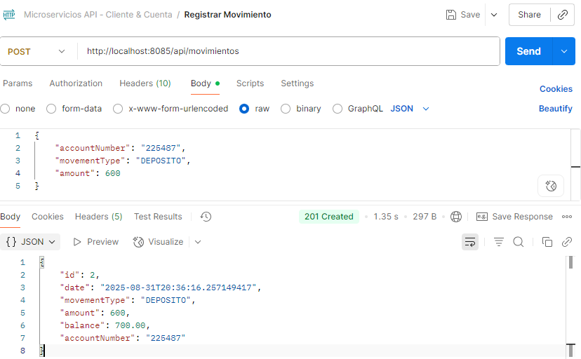

### Crear movimiento con saldo no disponible

**CURL:**

curl --location 'http://localhost:8085/api/movimientos' \

--header 'Content-Type: application/json' \

--**data** '{

    "accountNumber": "478758",

    "movementType": "RETIRO",

    "amount": -5000

}'

**RESPONSE:**

{

    "timestamp": "2025-08-31T20:51:50.41712747",

    "status": 400,

    "error": "Bad Request",

    "message": "Saldo no disponible",

    "path": "/api/movimientos"

}

**POSTMAN:**

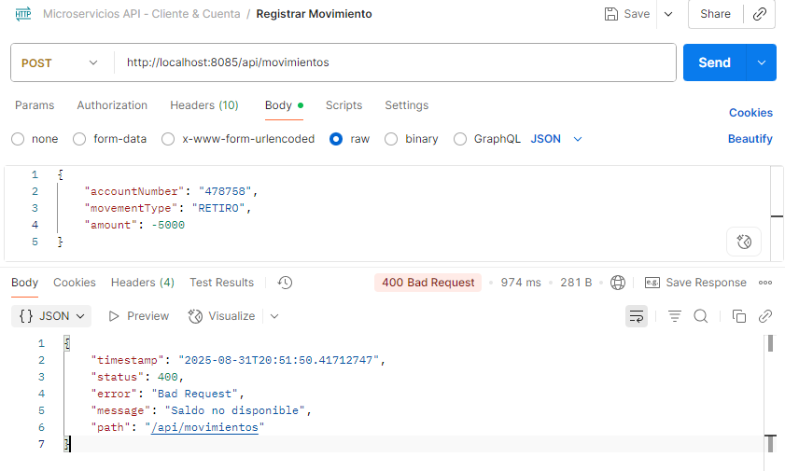

### Reporte

**CURL:**

curl --location 'http://localhost:8085/api/movimientos/reportes?desde=2025-08-31T00%3A00%3A00&hasta=2025-08-31T23%3A59%3A59&customer=CUST0002'

**RESPONSE:**

[

    {

        "date": "31/08/2025",

        "customerName": "Marianela Montalvo",

        "accountNumber": "225487",

        "accountType": "Corriente",

        "initialBalance": 100.00,

        "state": **false**,

        "movement": 600.00,

        "availableBalance": 700.00

    },

    {

        "date": "31/08/2025",

        "customerName": "Marianela Montalvo",

        "accountNumber": "496825",

        "accountType": "Ahorros",

        "initialBalance": 540.00,

        "state": **true**,

        "movement": -540.00,

        "availableBalance": 0.00

    }

]

**POSTMAN:**

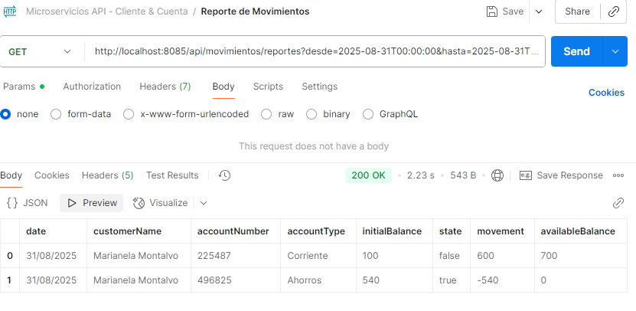

# TEST

## Crear Cliente

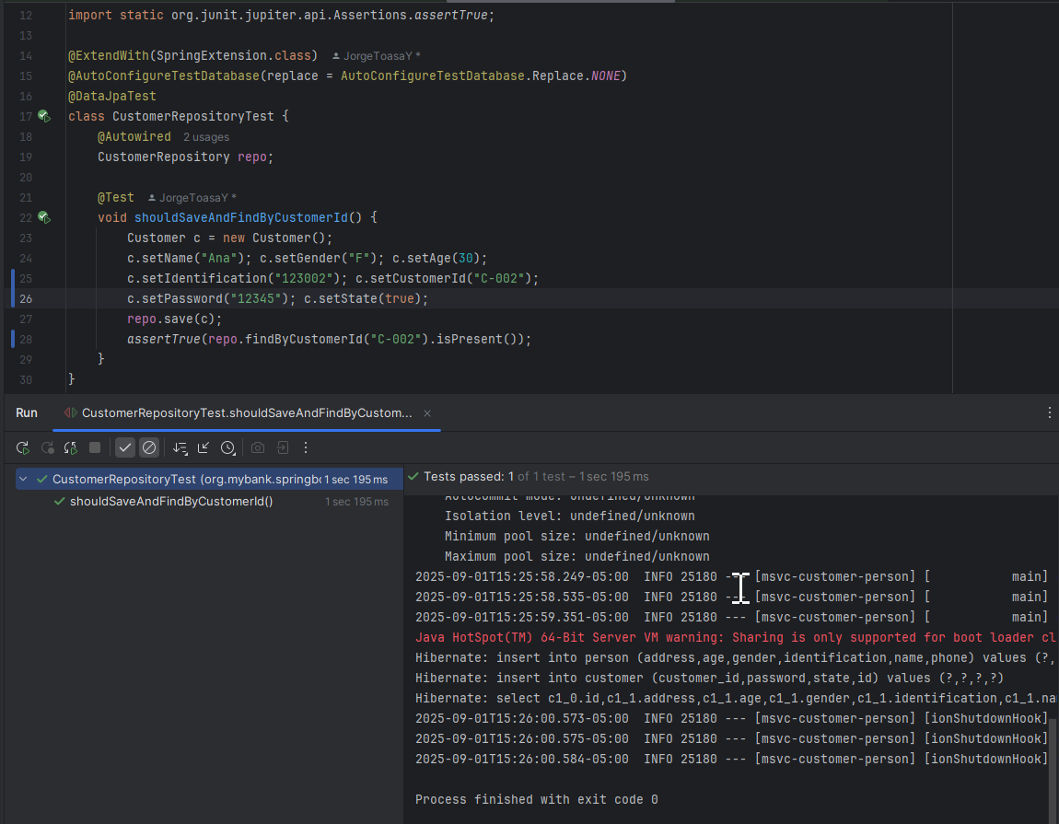

## Obtener Cliente

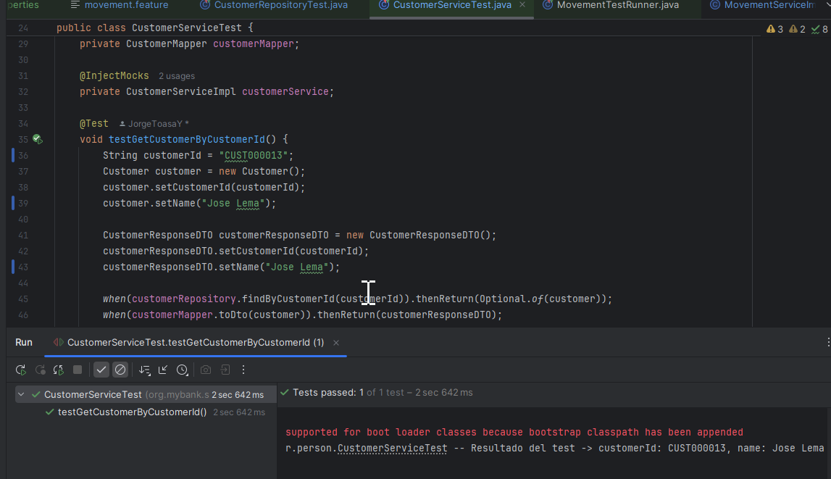

## Crear Cuenta y movimentos

